Figure List
PartⅠ
Chapter 2 Ground Improvement without Admixture in Non-cohesive soils or Fill
materials
Fig. 2.1 Compaction curve and Engineering Properties of Compacted Soil Mass
(Modified Figures after Lambe 1958)
Fig. 2.2 Governing Factors in Soil Compaction
Fig. 2.3 Compaction Curve vs. Compaction Energy (Ishibashi and Hazarika 2010)
Fig. 2.4 Range of field water content to achive the specified quality
Fig. 2.5 Field compaction equipments (Ishibasi and Hazarika, 2010)
Fig. 2.6 Effctof field compaction with depth and number of passes (D’Appolonia et.al., 1969).
Fig. 2.7 Work Flow of Compaction Method
Fig. 2.8 Loose sand and Vibration
Fig. 2.9 Grain size distribution curve and suitable range for Vibro-flotation
Fig. 2.10 Procedure of Vibro-flotation method
Fig. 2.11 Renewal work for pier by Vibro-flotation method
Fig. 2.12 Illustration on soil structure’s change during Tamping (Wood, 1968)
Fig. 2.13 Illustrated system and procedure of Heavy Tamping
Fig. 2.14 Ground behavior by Heavy Tamping passes (Yamada, 1991)
Fig. 2.15 Planning and Designing
Fig. 2.16 Procedure flow of Heavy Tamping

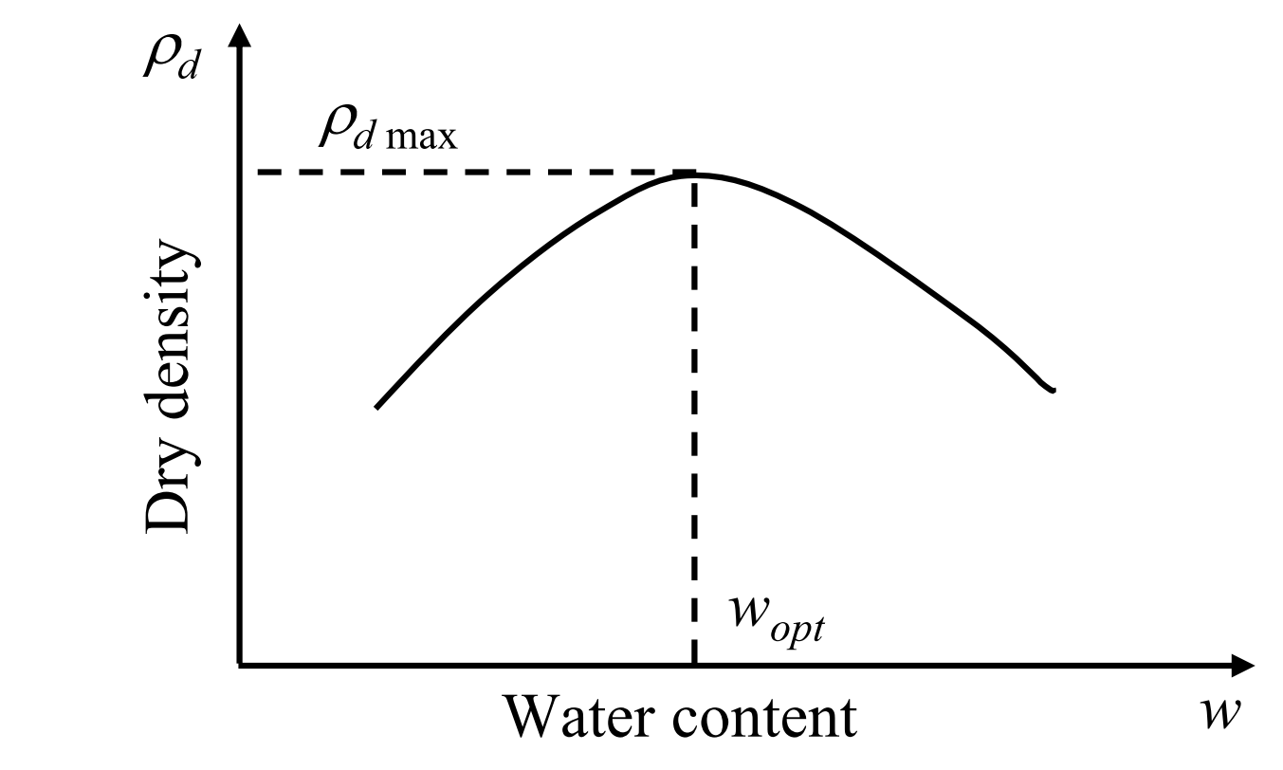
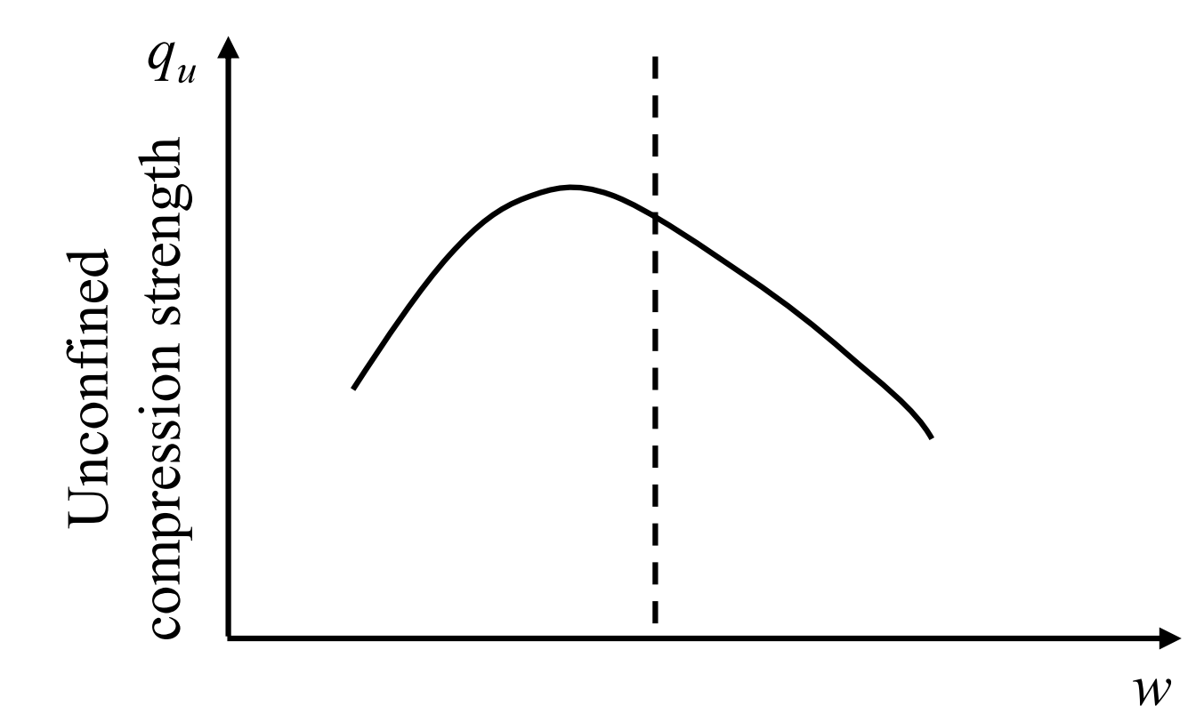
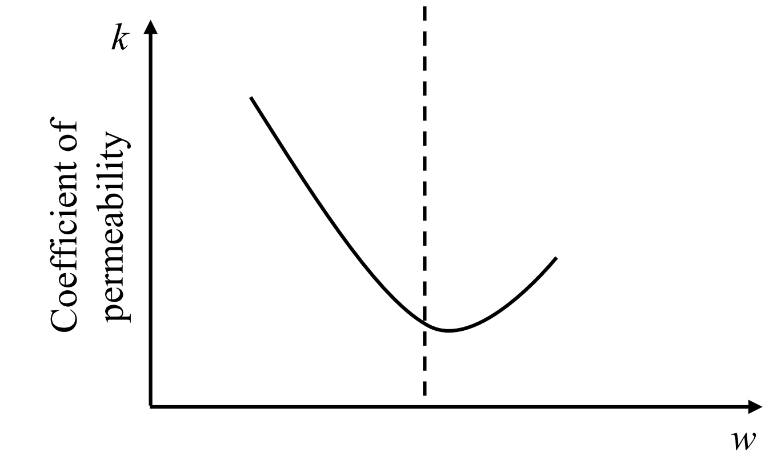
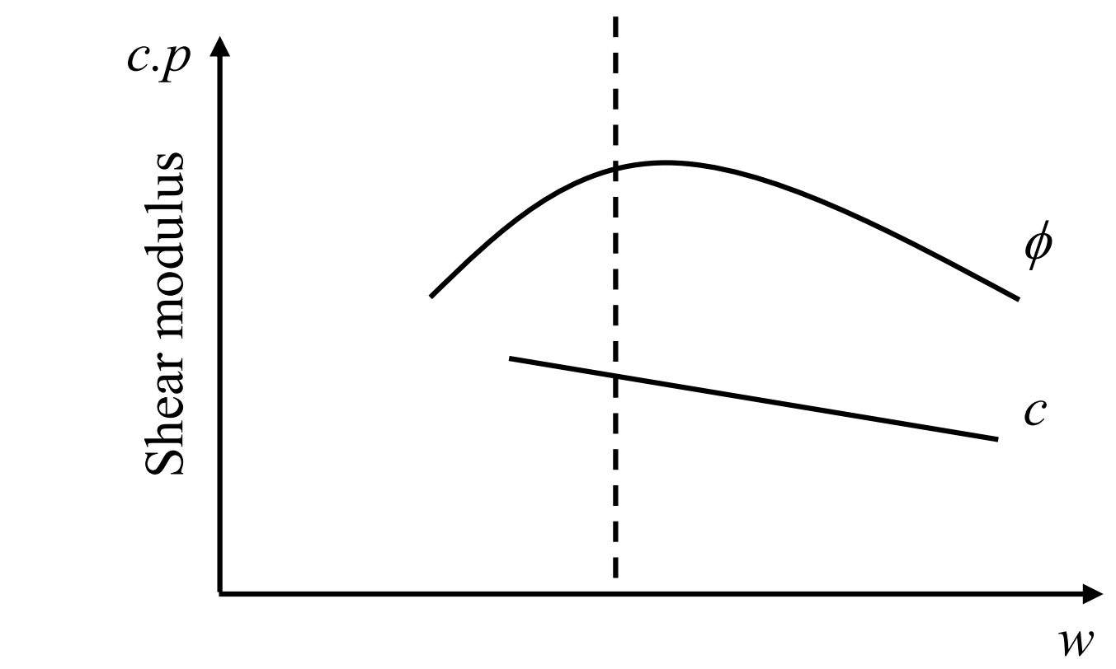
Fig. 2.1 Compaction curve and Engineering Properties of Compacted Soil Mass
(Original Chart by Lambe 1985, Modified)
Quality of Compacted soils
Water Content
Compaction Energy
Field Work
Materials

Fig. 2.2 Governing Factors in Soil Compaction

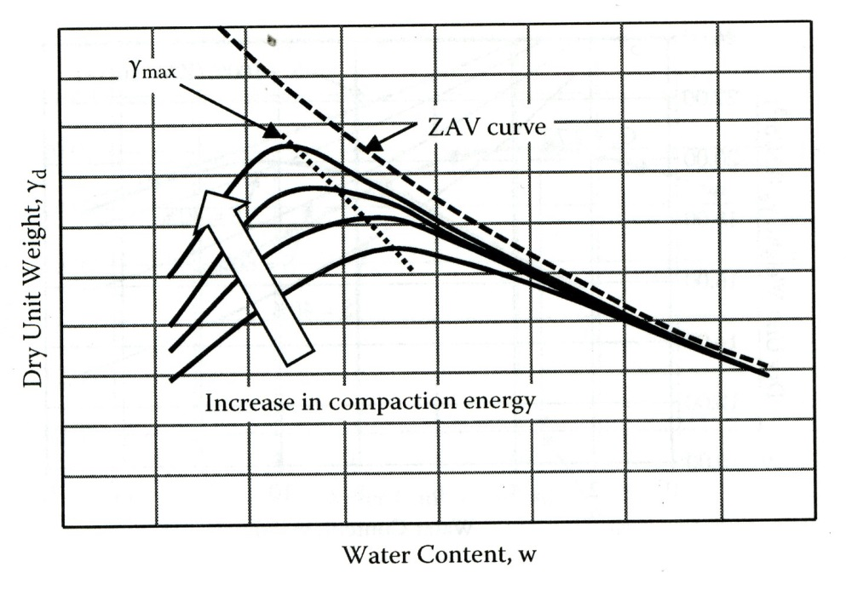

Fig. 2.3 Compaction Curve vs. Compaction Energy (Ishibashi and Hazarika 2010)
（オリジナルを入れる）

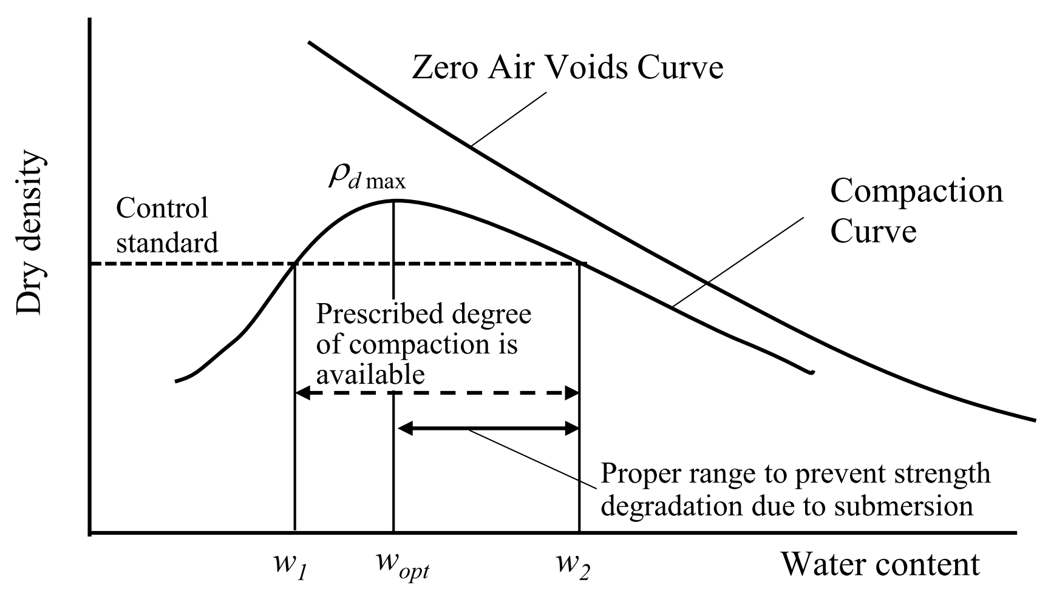

Fig. 2.4 Range of field water content to achive the specified quality

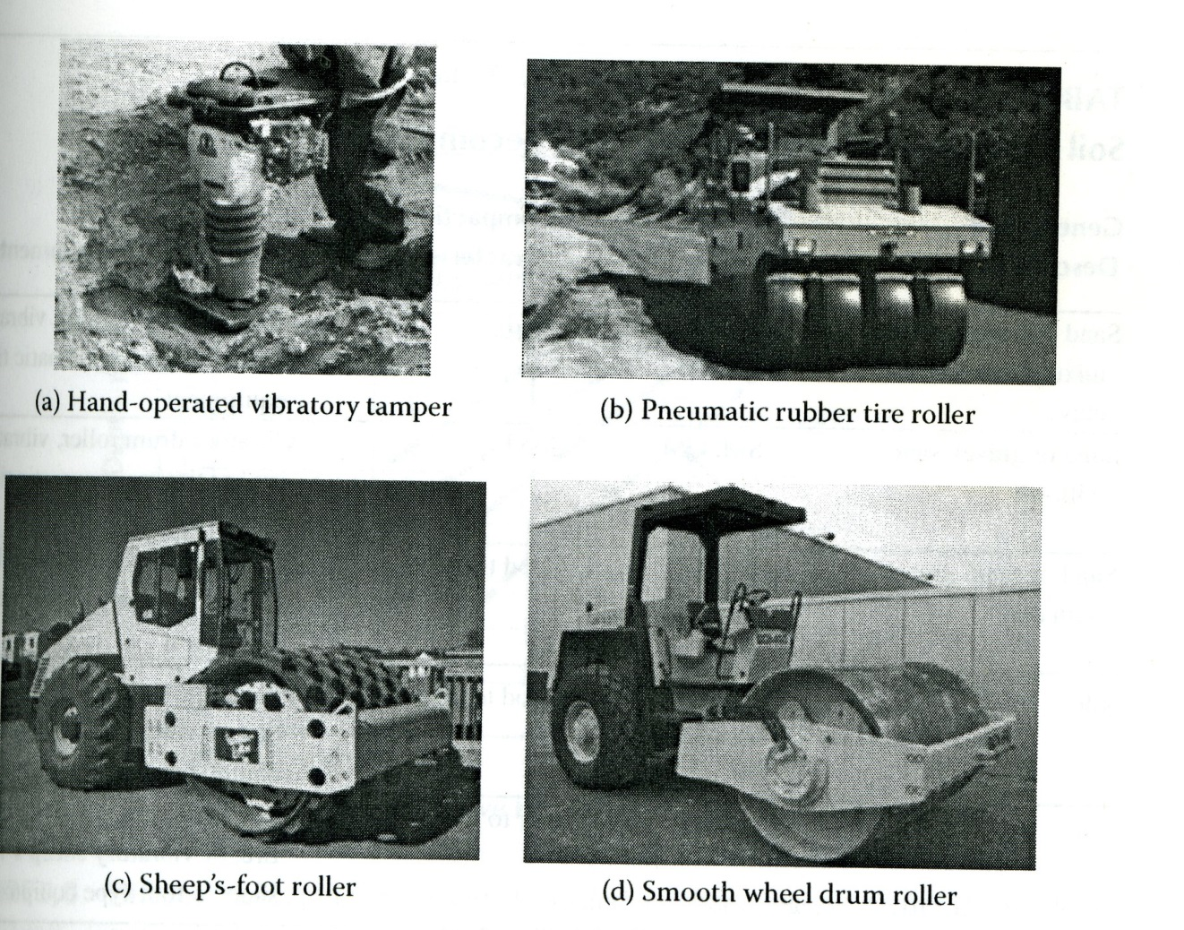
Fig. 2.5 Field compaction equipments (Ishibasi and Hazarika, 2010) （オリジナルを入れる）

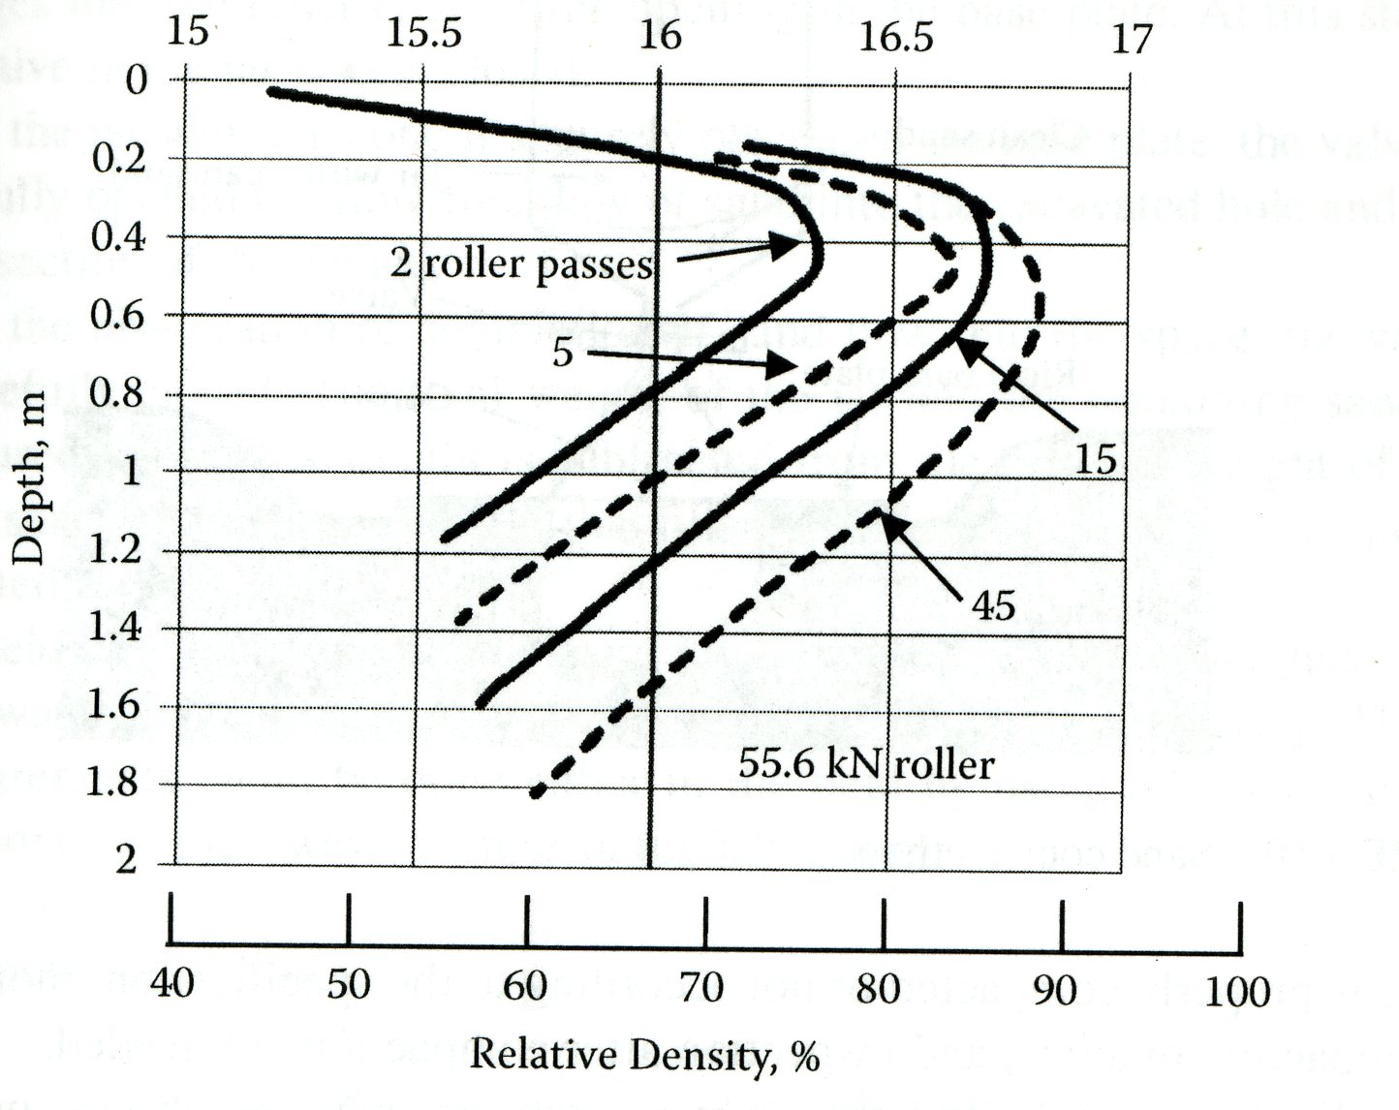
Fig. 2.6 Effctof field compaction with depth and number of passes (D’Appolonia et.al., 1969). （オリジナルを入れる）

Examination for Soil Materials
Checking of Design Conditions

Test Banking and Review

Decision of Construction Procedures
(Thickness of Soil Spreading,
Rolling Equipment
Rolling Number etc.)

Transportation and Spreading of Soil
Compacting Works

NO
Check of Final Dimension
YES
Treatment of Compacted Surface
End

Fig. 2.7 Work Flow of Compaction Method

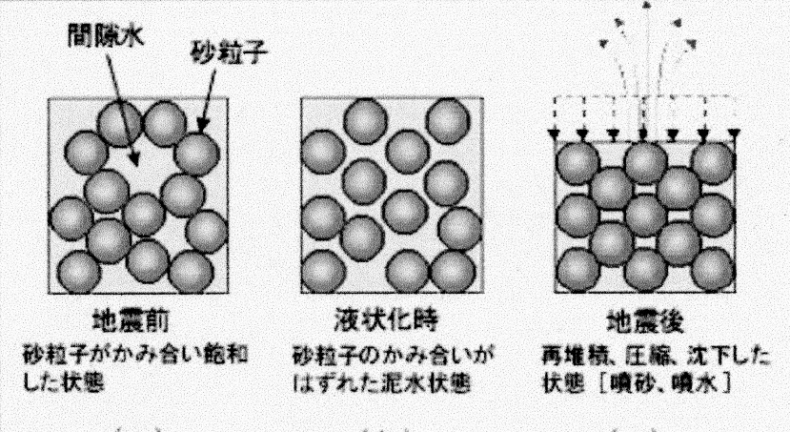
Sedimentary state
after vibrating action
Boiling
sand
Boiling
water
Liquefied state
under vibrating action
Loose state
before vibrating action
Loose state
before vibrating action
Soil particle
Pore water
Liquefied state
under vibrating action
Fig.2.8. Loose sand and Vibration (図を書き直す（学生アルバイト）)

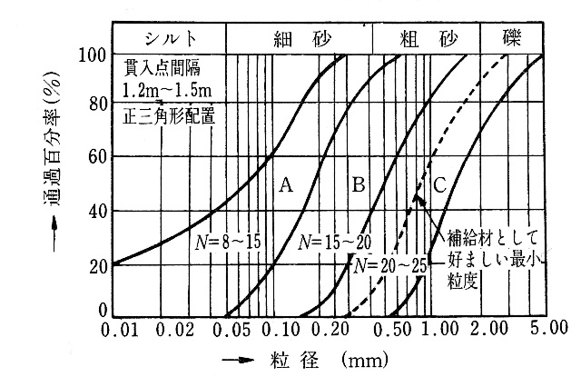
Under limit of grain size distribution curve of additional materials
Silt
Gravel
Coarse sand
Fine sand
Silt
Particle size (mm)

Note: N Estimated N-value after treatment
A Suitable zone B More suitable zone C Most suitable zone

Fig.2.9 Grain size distribution curve and suitable range for Vibro-flotation (Sourceを確認し、引用文献を入れる) または図を書きなす）
Condition:
Driving space 1.2 ~1.5 m at triangle pattern
Percentage passing (%)

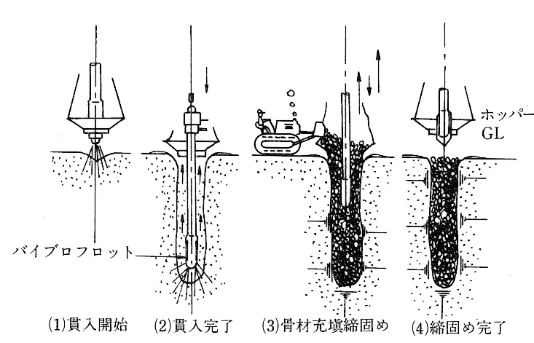
Hopper
(3) Supplying and compacting of aggregate materials
(2) Final stage of
penetration
Vibro-flot
Up and down
Down
(4) Final of treatment
(2) Final stage of
penetration
Water jet
(1) Starting

Fig.2.10 Procedure of Vibro-flotation method

(Dimensions are in m)
Treatment area B
Base of
crane
Treatment area A
Riprap
Steel pipe sheet-pile
φ=914.4mm
l = 16.0m
Vibro
flotation
Design head
-12.10
Tie rod
Anchoring buttress

Fig.2.11 Renewal work for pier by vibro-flotation method

(b) S wave and Rayleigh waves:
・Shear soil grains
・Rearrange structure towards denser state
(a) P wave:
・Increases pore water pressure
・Dislocates soil matrix

Fig. 2.12 Illustration on soil structure’s change during Tamping (Wood, 1968)

Fig. 2.13 Illustrated system and procedure of Heavy Tamping
（Wとwの修正）

Waiting
Waiting
Waiting
Strength q_{c}
Excess pore water pressure
Settlement
Time
Solid line : Sand
Dotted line : Clay
Tamping
Tamping
Tamping

Fig. 2.14 Ground behavior by consecutive Heavy Tamping passes. (Yamada, 1991)

Specifications of Tamping
Conditions for improvement
Dropping height
Weight of hammer
Dropping number
Location of dropping point
Site conditions
Ground conditions
Improving depth
Targets of improvement

Fig. 2.15 Planning and Designing （本文も含めてWeightとMassの定義の確認）

Preparation of working platform and tamping point
YES
NO

Execution of Dynamic consolidation (Tamping)

Backfilling of crater and re-tamping for it

Testing

Leveling of platform by all-over tamping

Fig.2.16 Procedure flow of heavy tamping

